UNIT-2
LAB PROGRAMS
NAME: VIJAY RAJESH R
REG NO: 23BAI10917

1.Write a Java program to find square root of a number without sqrt method.
import java.util.Scanner;

public class SquareRootCalculator {

// Method to calculate square root using Newton's method
public static double calculateSquareRoot(double number) {
if (number < 0) {
throw new IllegalArgumentException("Cannot compute square root of a negative number.");
}

double tolerance = 0.00001; // Define the tolerance level
double guess = number / 2.0; // Initial guess

// Iteratively improve the guess
while (Math.abs(guess * guess - number) > tolerance) {
guess = (guess + number / guess) / 2.0; // Update guess
}

return guess;
}

public static void main(String[] args) {
Scanner scanner = new Scanner(System.in);

// Input from user
System.out.print("Enter a number to find its square root: ");
double number = scanner.nextDouble();

try {
double squareRoot = calculateSquareRoot(number);
System.out.printf("Square Root of %.2f is approximately %.5f%n", number, squareRoot);
} catch (IllegalArgumentException e) {
System.out.println(e.getMessage());
} finally {
scanner.close();
}
}
}

2. Write a Java program for Student mark list display using class and methods.
package Assigment;
public class std_mark_list {
static String std_name;
static int std_id;
static int std_marks;

std_mark_list(String std_name,int std_id,int std_marks){
this.std_name=std_name;
this.std_id=std_id;
this.std_marks=std_marks;
}
static void show__student(String std_name,int std_id,int std_marks){
System.out.println("Name : "+std_name);
System.out.println("ID : "+std_id);
System.out.println("Marks : "+std_marks);
}
public static void main(String[] args) {
std_mark_list std___1 = new std_mark_list("Vijay", 635001, 98);
std___1.show__student(std_name, std_id, std_marks);

}
}
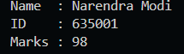
3.
Write a Java program for Employee details to calculate salary using
class and methods.
import java.util.Scanner;
class Employee {
private String name;
private String position;
private double baseSalary;
private double bonus;

public Employee(String name, String position, double baseSalary, double bonus) {
this.name = name;
this.position = position;
this.baseSalary = baseSalary;
this.bonus = bonus;
}

public double calculateSalary() {
return baseSalary + bonus;
}

public void displayDetails() {
System.out.println("Employee Name: " + name);
System.out.println("Position: " + position);
System.out.println("Base Salary: $" + baseSalary);
System.out.println("Bonus: $" + bonus);
System.out.println("Total Salary: $" + calculateSalary());
}
}

public class EmployeeSalaryApp {
public static void main(String[] args) {
Scanner scanner = new Scanner(System.in);

System.out.print("Enter employee name: ");
String name = scanner.nextLine();
System.out.print("Enter position: ");
String position = scanner.nextLine();
System.out.print("Enter base salary: ");
double baseSalary = scanner.nextDouble();
System.out.print("Enter bonus: ");
double bonus = scanner.nextDouble();

Employee employee = new Employee(name, position, baseSalary, bonus);
employee.displayDetails();

scanner.close();
}
}
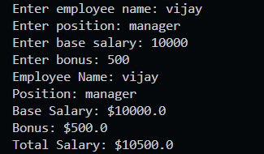
4.
Write a Java program for 3
Ways to initialize object using class.
class Person {
private String name;
private int age;

public Person(String name, int age) {
this.name = name;
this.age = age;
}

public void setDetails(String name, int age) {
this.name = name;
this.age = age;
}

public static Person createPerson(String name, int age) {
return new Person(name, age);
}

public void displayDetails() {
System.out.println("Name: " + name);
System.out.println("Age: " + age);
}
}

public class ObjectInitializationDemo {
public static void main(String[] args) {
Person person1 = new Person("Alice", 30);
person1.displayDetails();

Person person2 = new Person("", 0);
person2.setDetails("Bob", 25);
person2.displayDetails();

Person person3 = Person.createPerson("Charlie", 40);
person3.displayDetails();
}
}
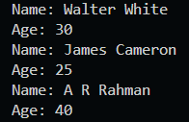
5.
Write a Java program for Predefined
and user-defined Method using class.
import java.util.Scanner;

package tf141;

import java.util.Scanner;

class Calculator {

// User-defined method to add two numbers
public int add(int a, int b) {
return a + b;
}

// User-defined method to calculate square of a number
public int square(int num) {
return num * num;
}
}

public class Main {
public static void main(String[] args) {
Scanner scanner = new Scanner(System.in);
Calculator calculator = new Calculator();

// Input for addition
System.out.print("Enter two numbers to add: ");
int num1 = scanner.nextInt();
int num2 = scanner.nextInt();
int sum = calculator.add(num1, num2);
System.out.println("Sum: " + sum);

// Input for square calculation
System.out.print("Enter a number to find its square: ");
int squareNum = scanner.nextInt();
int squareResult = calculator.square(squareNum);
System.out.println("Square: " + squareResult);

// Using a predefined method (Math.sqrt) to find square root
System.out.print("Enter a number to find its square root: ");
double sqrtNum = scanner.nextDouble();
double sqrtResult = Math.sqrt(sqrtNum);
System.out.println("Square root: " + sqrtResult);

scanner.close(); // Close the scanner to prevent resource leaks
}
}
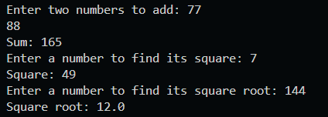

6.
Write a Java program for Employee details using constructor.
package Assigment;
public class emp_info_constuc {

String emp_name;
String emp_id;
int emp_sal;

//employee info using constructor
emp_info_constuc(String emp_name,String emp_id,int emp_sal){
this.emp_name=emp_name;
this.emp_id=emp_id;
this.emp_sal=emp_sal;
}

public static void main(String[] args) {
emp_info_constuc emp__1 = new emp_info_constuc("Vijay", "INFO2305", 100000);
System.out.println("Name : "+emp__1.emp_name);
System.out.println("ID : "+emp__1.emp_id);
System.out.println("Salary : "+emp__1.emp_sal);
}
}
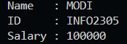

7.
Write a Java program for stack operations using constructor.
import java.util.Scanner;

class Stack {
private int maxSize, top;
private int[] stackArray;

public Stack(int size) {
maxSize = size;
stackArray = new int[maxSize];
top = -1;
}

public void push(int value) {
if (top < maxSize - 1) {
stackArray[++top] = value;
System.out.println("Pushed: " + value);
} else {
System.out.println("Stack is full.");
}
}

public int pop() {
if (top >= 0) {
return stackArray[top--];
} else {
System.out.println("Stack is empty.");
return -1;
}
}

public void display() {
if (top >= 0) {
System.out.print("Stack: ");
for (int i = top; i >= 0; i--) {
System.out.print(stackArray[i] + " ");
}
System.out.println();
} else {
System.out.println("Stack is empty.");
}
}
}

public class StackOperations {
public static void main(String[] args) {
Scanner scanner = new Scanner(System.in);
System.out.print("Enter stack size: ");
Stack stack = new Stack(scanner.nextInt());

while (true) {
System.out.println("\n1. Push 2. Pop 3. Display 4. Exit");
int choice = scanner.nextInt();
switch (choice) {
case 1:
System.out.print("Value to push: ");
stack.push(scanner.nextInt());
break;
case 2:
int popped = stack.pop();
if (popped != -1) System.out.println("Popped: " + popped);
break;
case 3:
stack.display();
break;
case 4:
scanner.close();
return;
default:
System.out.println("Invalid choice.");
}
}
}
}
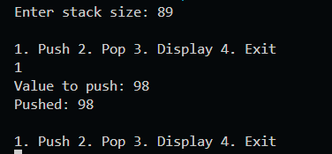
8.
Write a Java program for
area calculation (circle, square, rectangle, cone and triangle) using
constructor.
package Assigment;

public class Main
{
public static void main(String[] args)
{
Rectangle obj = new Rectangle();
obj.Area(30, 20);
obj.Area(12.5, 4.5);
Circle obj1 = new Circle();
obj1.Area(3);
obj1.Area(5.5);
Square obj2 = new Square();
obj2.Area(20);
obj2.Area(5.2);
}
}
class Square
{
void Area(double side)
{
System.out.println("Area of the Square: "+ side * side);
}
void Area(float side)
{
System.out.println("Area of the Square: "+ side * side);
}
}
class Circle
{
static final double PI = Math.PI;
void Area(double r)
{
double A = PI * r * r;
System.out.println("The area of the circle is :" + A);
}
void Area(float r)
{
double A = PI * r * r;
System.out.println("The area of the circle is :" + A);
}
}
class Rectangle
{
void Area(double l, double b)
{
System.out.println("Area of the rectangle: " + l * b);
}
void Area(int l, int b)
{
System.out.println("Area of the rectangle: " + l * b);
}
}
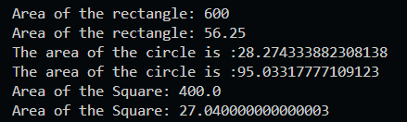
9.
Write a Java program for develop the functionality of calculator
using classes and methods with switch statements.
import java.util.Scanner;
class Calculator {
public double add(double a, double b) {
return a + b;
}

public double subtract(double a, double b) {
return a - b;
}

public double multiply(double a, double b) {
return a * b;
}

public double divide(double a, double b) {
if (b == 0) {
throw new ArithmeticException("Cannot divide by zero");
}
return a / b;
}
}

public class CalculatorApp {
public static void main(String[] args) {
Scanner scanner = new Scanner(System.in);
Calculator calculator = new Calculator();

System.out.println("Simple Calculator");
System.out.println("Select an operation:");
System.out.println("1. Addition (+)");
System.out.println("2. Subtraction (-)");
System.out.println("3. Multiplication (*)");
System.out.println("4. Division (/)");

System.out.print("Enter your choice (1-4): ");
int choice = scanner.nextInt();

System.out.print("Enter first number: ");
double num1 = scanner.nextDouble();
System.out.print("Enter second number: ");
double num2 = scanner.nextDouble();

switch (choice) {
case 1:
System.out.println("Result: " + calculator.add(num1, num2));
break;
case 2:
System.out.println("Result: " + calculator.subtract(num1, num2));
break;
case 3:
System.out.println("Result: " + calculator.multiply(num1, num2));
break;
case 4:
try {
System.out.println("Result: " + calculator.divide(num1, num2));
} catch (ArithmeticException e) {
System.out.println(e.getMessage());
}
break;
default:
System.out.println("Invalid choice! Please select a valid operation.");
}

scanner.close();
}
}
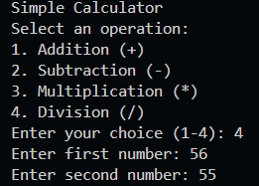
10. Write a Java program for
Factorial Number and Fibonacci Series using Recursion.
import java.util.Scanner;
public class RecursiveMath {

public static long factorial(int n) {
if (n == 0 || n == 1) {
return 1;
}
return n * factorial(n - 1);
}
public static int fibonacci(int n) {
if (n <= 0) {
return 0;
} else if (n == 1) {
return 1;
}
return fibonacci(n - 1) + fibonacci(n - 2);
}
public static void main(String[] args) {
Scanner scanner = new Scanner(System.in);

System.out.print("Enter a number to calculate its factorial: ");
int factInput = scanner.nextInt();
long factResult = factorial(factInput);
System.out.println("Factorial of " + factInput + " is: " + factResult);
System.out.print("Enter the number of Fibonacci terms to generate: ");
int fibInput = scanner.nextInt();
System.out.println("Fibonacci series up to " + fibInput + " terms:");
for (int i = 0; i < fibInput; i++) {
System.out.print(fibonacci(i) + " ");
}
System.out.println();
scanner.close();
}
}
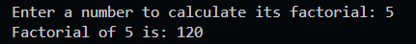
11. Write a java Program for
all types of inheritance.
class GrandParent {
void display() {
System.out.println("This is the GrandParent class.");
}
}

class Parent extends GrandParent {
void show() {
System.out.println("This is the Parent class.");
}
}

class Child extends Parent {
void output() {
System.out.println("This is the Child class.");
}
}

class AnotherChild extends Parent {
void displayAnother() {
System.out.println("This is Another Child class.");
}
}

public class InheritanceDemo {
public static void main(String[] args) {
Child child = new Child();
child.display();
child.show();
child.output();

AnotherChild anotherChild = new AnotherChild();
anotherChild.display();
anotherChild.show();
anotherChild.displayAnother();
}
}
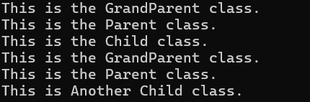
12. Write a java Program for
three usage of super keyword.
class Parent {
int num = 100;
Parent() {
System.out.println("Parent class constructor");
}
void display() {
System.out.println("Parent class method");
}
}

class Child extends Parent {
int num = 200;
Child() {
super();
System.out.println("Child class constructor");
}
void display() {
super.display();
System.out.println("Child class method");
}
void printNumber() {
System.out.println("Child num: " + num);
System.out.println("Parent num: " + super.num);
}
}

public class {
public static void main(String[] args) {
Child obj = new Child();
obj.display();
obj.printNumber();
}
}
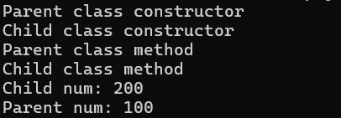
13. Write a java Program for
Employee details using super keyword.
class Employee {
String name;
int id;

Employee(String name, int id) {
this.name = name;
this.id = id;
}

void display() {
System.out.println("Employee Name: " + name);
System.out.println("Employee ID: " + id);
}
}

class Manager extends Employee {
String department;

Manager(String name, int id, String department) {
super(name, id);
this.department = department;
}

void display() {
super.display();
System.out.println("Department: " + department);
}
}

public class EmployeeDetails {
public static void main(String[] args) {
Manager manager = new Manager("John Doe", 101, "IT");
manager.display();
}
}
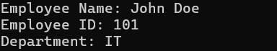
14. Write a java Program for
Bank interest calculation using Method
Overriding.
class Bank {
double getRateOfInterest() {
return 0;
}
}

class SBI extends Bank {
double getRateOfInterest() {
return 5.5;
}
}

class ICICI extends Bank {
double getRateOfInterest() {
return 6.0;
}
}

class Axis extends Bank {
double getRateOfInterest() {
return 6.5;
}
}

public class {
public static void main(String[] args) {
Bank sbi = new SBI();
Bank icici = new ICICI();
Bank axis = new Axis();

System.out.println("SBI Rate of Interest: " + sbi.getRateOfInterest() + "%");
System.out.println("ICICI Rate of Interest: " + icici.getRateOfInterest() + "%");
System.out.println("Axis Rate of Interest: " + axis.getRateOfInterest() + "%");
}
}
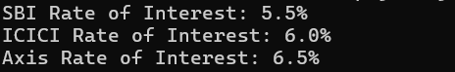
15. Write a java Program for
area calculation using run-time
polymorphism.
class Shape {
// Method to calculate area (will be overridden in derived classes)
double calculateArea() {
System.out.println("Area calculation for shape.");
return 0;
}
}

class Rectangle extends Shape {
double length, width;

Rectangle(double length, double width) {
this.length = length;
this.width = width;
}

@Override
double calculateArea() {
return length * width;
}
}

class Circle extends Shape {
double radius;

Circle(double radius) {
this.radius = radius;
}

@Override
double calculateArea() {
return Math.PI * radius * radius;
}
}

public class Main {
public static void main(String[] args) {

Shape shape1 = new Rectangle(10, 5);
System.out.println("Area of Rectangle: " + shape1.calculateArea());

Shape shape2 = new Circle(7);
System.out.println("Area of Circle: " + shape2.calculateArea());
}
}
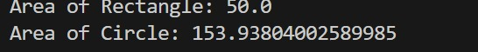
16. Write a java Program for
area calculation using abstract class and methods.
abstract class Shape {

abstract double calculateArea();
}

class Rectangle extends Shape {
double length, width;

Rectangle(double length, double width) {
this.length = length;
this.width = width;
}

@Override
double calculateArea() {
return length * width;
}
}

class Circle extends Shape {
double radius;

Circle(double radius) {
this.radius = radius;
}

@Override
double calculateArea() {
return Math.PI * radius * radius;
}
}

public class Main {
public static void main(String[] args) {

Shape shape1 = new Rectangle(10, 5);
System.out.println("Area of Rectangle: " + shape1.calculateArea());

Shape shape2 = new Circle(7);
System.out.println("Area of Circle: " + shape2.calculateArea());
}
}
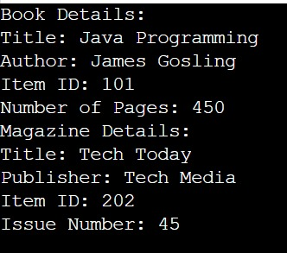
17. Write a java Program for Library
management details using abstract class and methods.
abstract class LibraryItem {
String title;
String authorOrPublisher;
int itemId;

// Constructor
LibraryItem(String title, String authorOrPublisher, int itemId) {
this.title = title;
this.authorOrPublisher = authorOrPublisher;
this.itemId = itemId;
}

// Abstract method to display details
abstract void displayDetails();
}

// Derived class Book
class Book extends LibraryItem {
int numberOfPages;

// Constructor
Book(String title, String author, int itemId, int numberOfPages) {
super(title, author, itemId);
this.numberOfPages = numberOfPages;
}

// Implementing abstract method to display book details
@Override
void displayDetails() {
System.out.println("Book Details:");
System.out.println("Title: " + title);
System.out.println("Author: " + authorOrPublisher);
System.out.println("Item ID: " + itemId);
System.out.println("Number of Pages: " + numberOfPages);
}
}

// Derived class Magazine
class Magazine extends LibraryItem {
int issueNumber;

// Constructor
Magazine(String title, String publisher, int itemId, int issueNumber) {
super(title, publisher, itemId);
this.issueNumber = issueNumber;
}

// Implementing abstract method to display magazine details
@Override
void displayDetails() {
System.out.println("Magazine Details:");
System.out.println("Title: " + title);
System.out.println("Publisher: " + authorOrPublisher);
System.out.println("Item ID: " + itemId);
System.out.println("Issue Number: " + issueNumber);
}
}

public class Main {
public static void main(String[] args) {
// Creating a Book object
LibraryItem book = new Book("Java Programming", "James Gosling", 101, 450);
book.displayDetails();

// Creating a Magazine object
LibraryItem magazine = new Magazine("Tech Today", "Tech Media", 202, 45);
magazine.displayDetails();
}
}

18. Write a java Program for
student details using Encapsulation.
class Student {
// Private fields (data members)
private String name;
private int rollNumber;
private String course;
private double grade;

// Constructor to initialize student details
public Student(String name, int rollNumber, String course, double grade) {
this.name = name;
this.rollNumber = rollNumber;
this.course = course;
this.grade = grade;
}

// Getter for name
public String getName() {
return name;
}

// Setter for name
public void setName(String name) {
this.name = name;
}

// Getter for roll number
public int getRollNumber() {
return rollNumber;
}

// Setter for roll number
public void setRollNumber(int rollNumber) {
this.rollNumber = rollNumber;
}

// Getter for course
public String getCourse() {
return course;
}

// Setter for course
public void setCourse(String course) {
this.course = course;
}

// Getter for grade
public double getGrade() {
return grade;
}

// Setter for grade
public void setGrade(double grade) {
this.grade = grade;
}

// Method to display student details
public void displayDetails() {
System.out.println("Student Details:");
System.out.println("Name: " + name);
System.out.println("Roll Number: " + rollNumber);
System.out.println("Course: " + course);
System.out.println("Grade: " + grade);
}
}

public class Main {
public static void main(String[] args) {
// Creating a Student object using constructor
Student student = new Student("Alice", 101, "Computer Science", 9.5);

// Display initial student details
student.displayDetails();

// Modifying student details using setters
student.setName("Bob");
student.setRollNumber(102);
student.setCourse("Mechanical Engineering");
student.setGrade(8.9);

// Display updated student details
System.out.println("\nUpdated Student Details:");
student.displayDetails();
}
}
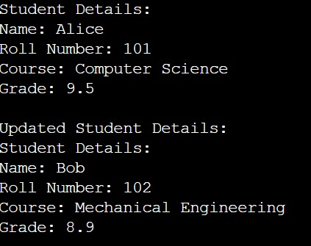

19. Write a java Program for Anonymous inner class and outer class
class OuterClass {
void display() {
System.out.println("Inside OuterClass");
}

void methodWithAnonymousInnerClass() {
new InnerClass() {
void display() {
System.out.println("Inside Anonymous InnerClass");
}
}.display();
}

class InnerClass {
void display() {
System.out.println("Inside InnerClass");
}
}
}

public class Main {
public static void inclassoutclass (String[] args) {
OuterClass outer = new OuterClass();
outer.display();
outer.methodWithAnonymousInnerClass();
}
}

20. Write a java Program for Singleton class.
class Singleton {
private static Singleton instance = null;

private Singleton() {}

public static Singleton getInstance() {
if (instance == null) {
instance = new Singleton();
}
return instance;
}

public void displayMessage() {
System.out.println("Singleton Instance");
}
}

public class Main {
public static void singletonclass (String[] args) {
Singleton singleton1 = Singleton.getInstance();
Singleton singleton2 = Singleton.getInstance();

singleton1.displayMessage();
System.out.println(singleton1 == singleton2); // true
}
}

21. Write a java Program for Reflection.
import java.lang.reflect.Method;
import java.lang.reflect.Field;
import java.lang.reflect.Constructor;

class SampleClass {
private String name;

public SampleClass() {}

public void setName(String name) {
this.name = name;
}

public String getName() {
return this.name;
}
}

public class ReflectionExample {
public static void main(String[] args) {
try {
Class<?> sampleClass = SampleClass.class;

Constructor<?> constructor = sampleClass.getConstructor();
Object instance = constructor.newInstance();

Method setNameMethod = sampleClass.getMethod("setName", String.class);
setNameMethod.invoke(instance, "Reflection");

Method getNameMethod = sampleClass.getMethod("getName");
String name = (String) getNameMethod.invoke(instance);
System.out.println(name);

Field fieldName = sampleClass.getDeclaredField("name");
fieldName.setAccessible(true);
fieldName.set(instance, "Modified by Reflection");
System.out.println(fieldName.get(instance));

} catch (Exception e) {
e.printStackTrace();
}
}
}

